1. Where (which directory path) is your SOF file located, and what it is called

SOF file is located in **Cassiel_Jung_33294968_Lab_Lab2/rtl/template_de1soc**

1. What is the status of the lab (what works, what doesn't)

Able to done everything (‘E’-start, ‘D’-stop, ‘F’-forward, ‘B’-backward, ‘KEY0’-faster, ‘KEY1’-slower, ‘KEY2’-reset frequency). For bonus, was able to reset the address by pressing ‘R’ but the song stops even if it was playing. Should press ‘E’ again to start again.

1. Annotated simulation screenshots as required by the lab

PDF file of screenshots is located in **Cassiel_Jung_33294968_Lab_Lab2/sim**

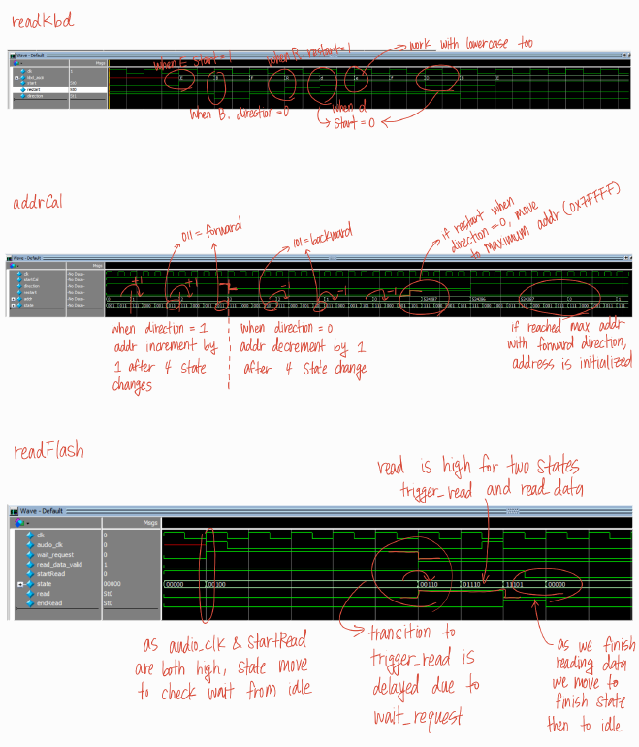

1. Annotated SignalTap screenshots as required by the lab

PDF file of screenshots is located in **Cassiel_Jung_33294968_Lab_Lab2/sim**

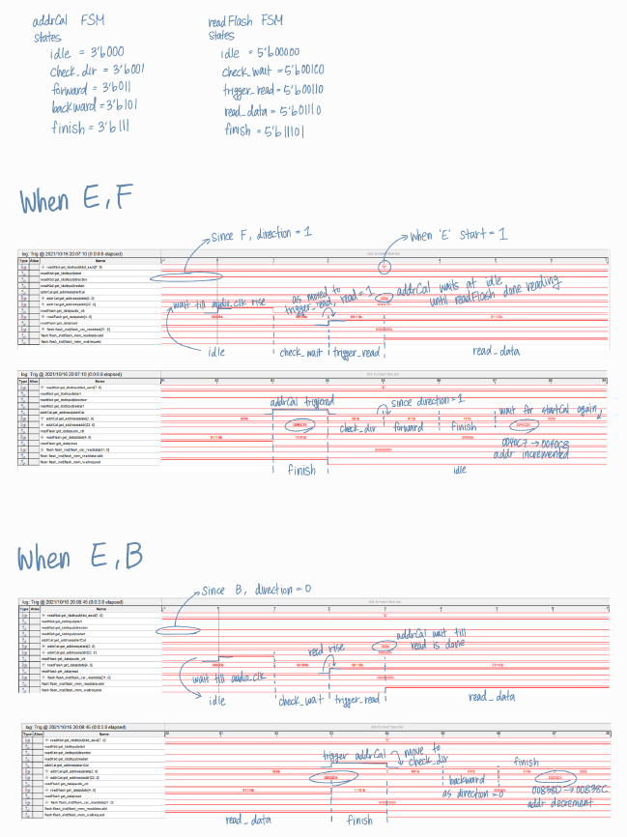

1. Information on how to run the simulations (i.e. where the files are located, which program you used to run your simulation)

For modelSim simulation, go to **Cassiel_Jung_33294968_Lab_Lab2/sim/lab2_tb** folder. It has modelSim project file, Verilog codes and testbenches as well as wave format (.do file)

Files for signalTap is located in **Cassiel_Jung_33294968_Lab_Lab2/rtl/template_de1soc**

Use Quartus-signalTap for the simulation. Should compile the SOF file, configure the program on the DE1 board, run **lcd_scope.stp.**

1. Any additional information that would be relevant for the TA marking your project.

Flow chart is in **Cassiel_Jung_33294968_Lab_Lab2/doc**